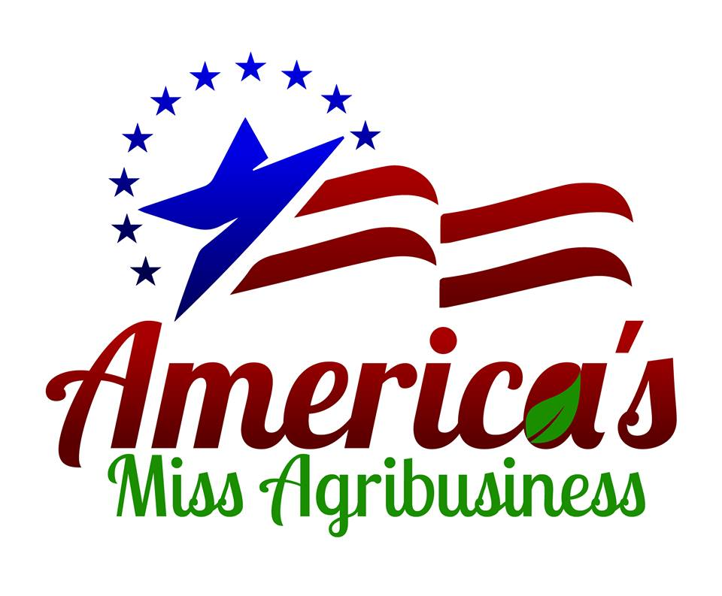
America’s Miss Agribusiness Alabama State Pageant 2020
Friends and Family Sponsorship Program
Queens Name: ____________________________________

I need your help! I am working towards the America’s Miss Agribusiness Alabama State Cover Miss State Title! I need 10 sponsors who are willing to sponsor me for just $20 (you may sponsor me for more if you’d like) … Just make sure to print your name clearly on the lines below ($20– One Line, $40 – Two Lines, $60 Three Lines, etc). The America’s Miss Agribusiness Pageant Program is a scholarship program that focuses on teaching girls the importance of giving back to their communities. In addition, our goals are to build leadership skills and self confidence in our future female leaders. Thank you for helping to make it possible for me to have this experience and compete for scholarship funds for my future.

1. ____________________________________ 6. ____________________________________

2. ____________________________________ 7. ____________________________________

3. ____________________________________ 8. ____________________________________

4. ____________________________________ 9. ____________________________________

5. ____________________________________ 10. ___________________________________

Please forward this form along with funds collected to:
Jacque Listau, Associate National Director
4050 Cooper Lane, Holt, Florida 32564
(PayPal accepted at jacquealistau@gmail.com)

